Fitness Gym Membership System

1. **Creating the tables**

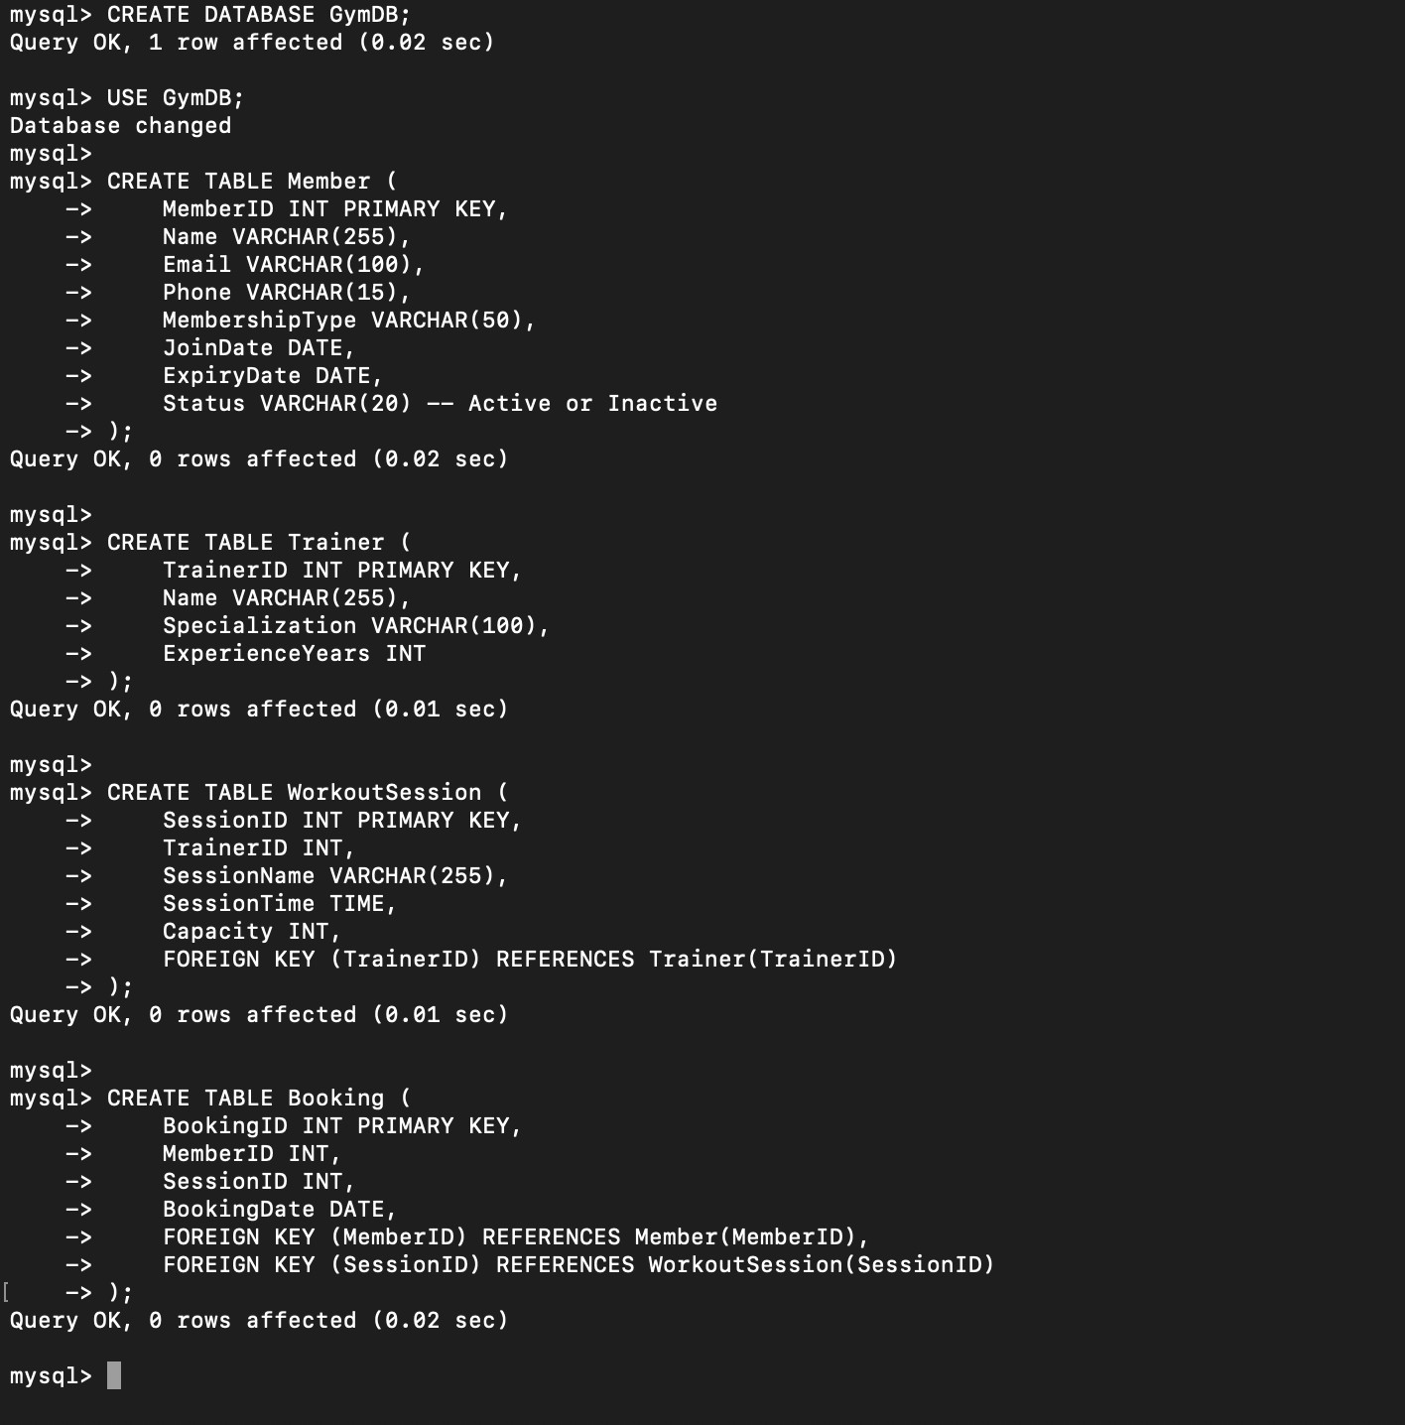

1. **Inserting sample data**

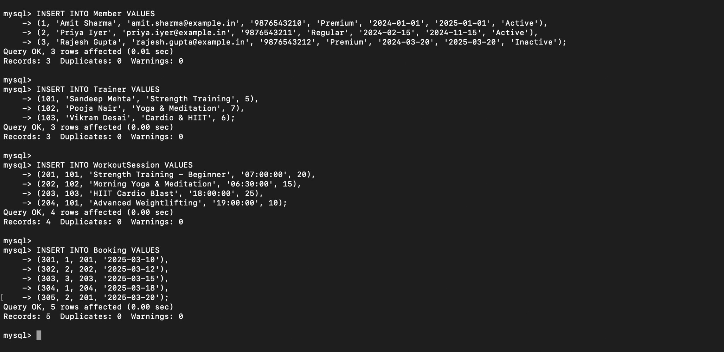

1. **Retrieve active members with premium membership**

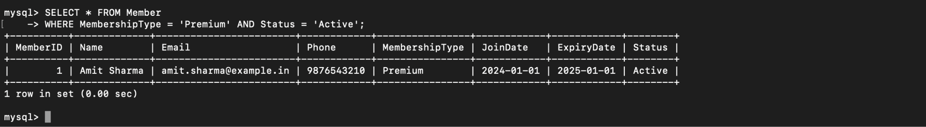

1. **Find trainers who have the most members assigned**

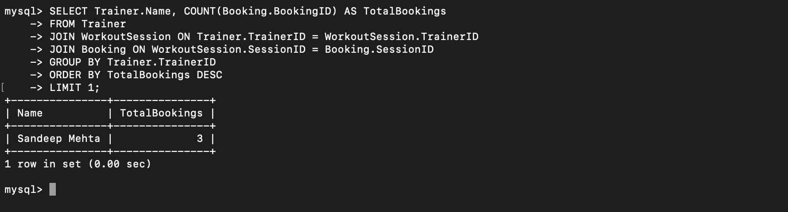

1. **Retrieve all bookings for a specific workout session**

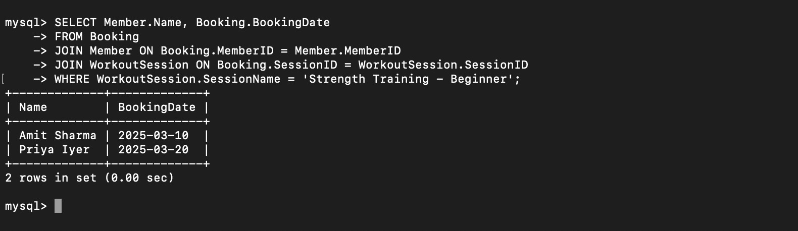

1. **Find the most popular workout session**

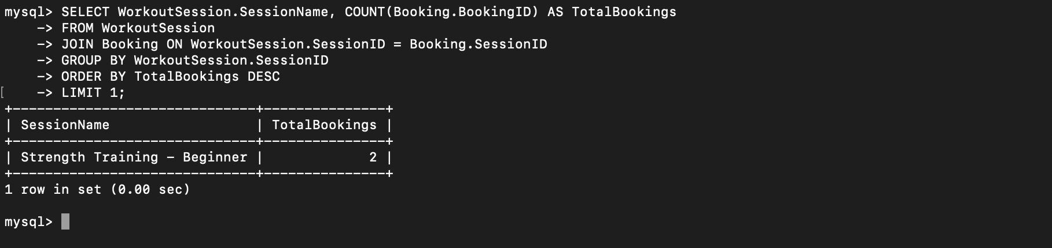

1. **Display memberships expiring in the next 30 days**

